**Solutie pentru a ne da seama unde avem NO DATA FOUND daca exista mai multe intr-un bloc**

Folosim tot tabela emp_ido unde employee_id este de la 100 pana la 206.

Sa spunem ca avem urmatorul cod:  
  
DECLARE

id NUMBER(6);

BEGIN

SELECT employee_id

INTO id

FROM emp_ido

WHERE employee_id = 1000;

DBMS_OUTPUT.PUT_LINE(id);

SELECT employee_id

INTO id

FROM emp_ido

WHERE employee_id = 1001;

DBMS_OUTPUT.PUT_LINE(id);

SELECT employee_id

INTO id

FROM emp_ido

WHERE employee_id = 1002;

DBMS_OUTPUT.PUT_LINE(id);

END;

Bineinteles ca nu exista niciun employee nici cu id-ul 1000, nici cu 1001 nici cu 1002. Cand rulam:  
  
  
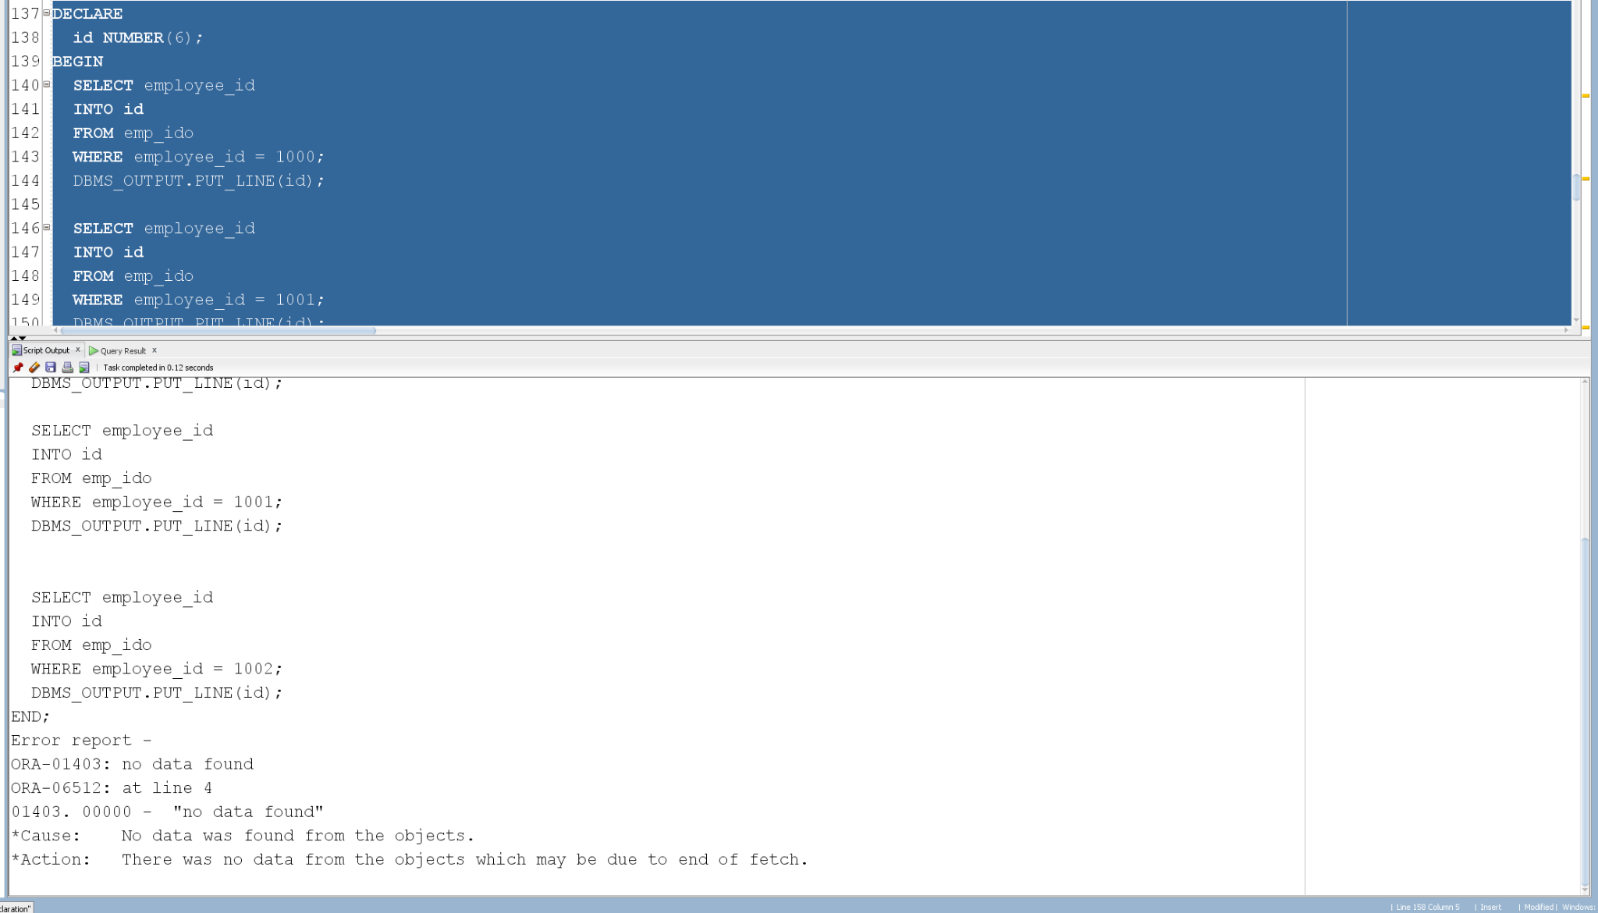

Gasim eroarea de NO DATA FOUND, dar nu stim exact unde am gasit aceasta eroare. O simpla solutie pentru aceasta situatie, cand avem mai multe erori de NO DATA FOUND intr-un bloc e sa tratam fiecare situatie in care ne-am putea confrunta cu aceasta eroare intr-un bloc de sine statator care sa trateze exceptia si sa ofere un mesaj cu o informatie pentru programator sa-si dea seama exact unde gasim eroarea respectiva. Pentru codul anterior, il putem transforma:  
  
DECLARE

id NUMBER(6);

BEGIN

BEGIN

SELECT employee_id

INTO id

FROM emp_ido

WHERE employee_id = 1000;

DBMS_OUTPUT.PUT_LINE('Employee 1000: ' || id);

EXCEPTION

WHEN NO_DATA_FOUND THEN

DBMS_OUTPUT.PUT_LINE('No data found pentru Employee 1000');

END;

BEGIN

SELECT employee_id

INTO id

FROM emp_ido

WHERE employee_id = 1001;

DBMS_OUTPUT.PUT_LINE('Employee 1001: ' || id);

EXCEPTION

WHEN NO_DATA_FOUND THEN

DBMS_OUTPUT.PUT_LINE('No data found pentru Employee 1001');

END;

BEGIN

SELECT employee_id

INTO id

FROM emp_ido

WHERE employee_id = 101;

DBMS_OUTPUT.PUT_LINE('Employee 101: ' || id);

EXCEPTION

WHEN NO_DATA_FOUND THEN

DBMS_OUTPUT.PUT_LINE('No data found pentru Employee 101');

END;

BEGIN

SELECT employee_id

INTO id

FROM emp_ido

WHERE employee_id = 1002;

DBMS_OUTPUT.PUT_LINE('Employee 1002: ' || id);

EXCEPTION

WHEN NO_DATA_FOUND THEN

DBMS_OUTPUT.PUT_LINE('No data found pentru Employee 1002');

END;

END;

